The ten dimensions of good board performance (including template FOR A board improvement plan)
Overview
The board performance evaluation framework for Jamaican public bodies will assess the performance of:
- Public body boards
- Board committees
- Board Chairs, and
- Individual board members
Taking account of a range of better practice governance standards and principles for boards, we propose that the performance of public body boards and board members be assessed against 10 dimensions of good board performance as illustrated in the diagram below:

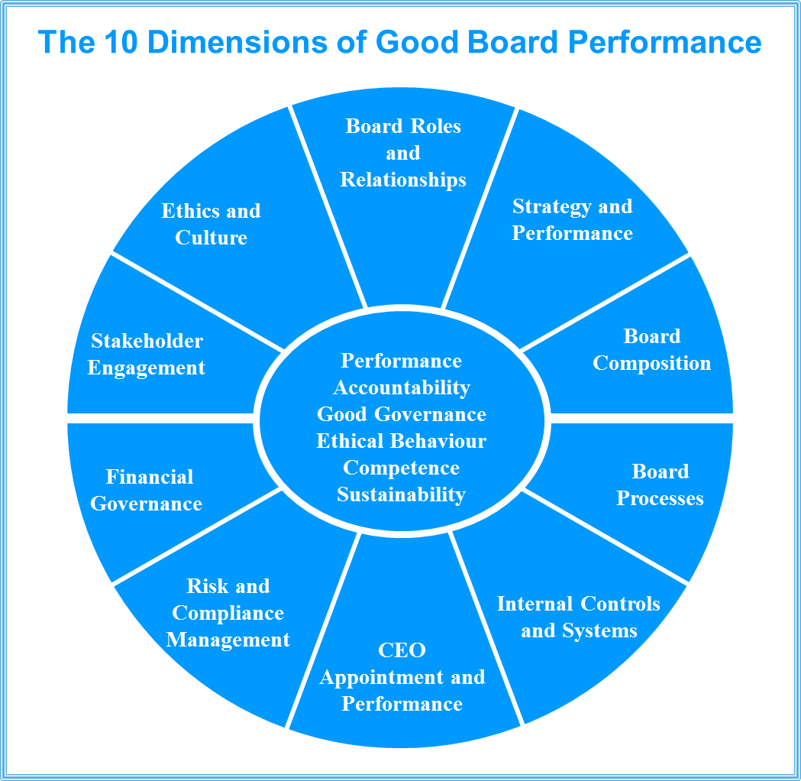
The 10 dimensions of good board performance
The ten dimensions of good board performance are defined as:

- Roles and relationships: The board and board members have a clear understanding of their roles, responsibilities and accountabilities and the relationship between the board and the Minister, the CEO and the Permanent Secretary. There is also a shared understanding of the respective roles and responsibilities of the board and the role of management, including in relationship to the public body’s responsibilities for Corporate Social Responsibility.
- Board composition: The board collectively has the right mix of skills, competencies, experience and diversity to enable the public body to achieve its purpose and strategy efficiently and effectively.
- Ethics and culture: The board sets the tone at the top for ethical behavior and promotes adherence to core values through its attitudes and behaviours within the boardroom and across the public body. The board ensures that conflicts of interest are identified and managed transparently and appropriately.
- Strategy and performance: The board sets the vision and strategic direction of the public body, and associated key performance indicators, and monitors the public body’s performance against them. The corporate plan is designed to achieve the organisation’s objectives. The strategic direction as embodied in the corporate plan is agreed with the relevant Minister.
- Internal controls and systems: The board ensures that management establishes and maintains an effective control framework (including relevant policies, procedures and systems and robust and transparent management processes) so that the performance of the public body can be monitored.
- Risk and compliance management: The board knows the public body’s key risks (including compliance risks), establishes the risk appetite within which the public body can operate, and ensures that management has implemented an appropriate framework for the identification, assessment, management and reporting of risk.
- CEO appointment and performance: The board has approved appropriate policies for the recruitment and remuneration of the CEO and sets, monitors and formally reviews the performance of the CEO.
- Financial governance: The board ensures the public body’s sustainability is enhanced through effective budgeting, financial management, reporting and auditing.
- Board processes: The board operates efficiently and effectively through forward planning its activities, managing its papers effectively, annual evaluation of board performance and making effective use of board committees.
- Stakeholder engagement: The board ensures the public body knows who its stakeholders are and has a strategy for engaging and communicating with them.
We have mapped the ten dimensions and their attributes against the Corporate Governance Framework for Public Bodies in Jamaica (2012) and the draft Competency Profile Instrument for the Boards of Public Bodies (2016) to ensure that they are consistent with them and that there are no gaps.
Proposed board as-a-whole evaluation framework
Set out below are the attributes of good board performance for each of the ten dimensions of good board performance.
.
Each board member (and potentially also key executive managers who regularly interface with the board) will be asked to provide feedback as to how well their board demonstrates the requisite attributes outlined above through a board as-a-whole survey.
Survey responses will be collated in a de-identified way (potentially by the corporate secretary) into a survey report.
We would expect that the board would then use the report to identify areas for improvement in their governance and processes.
To ensure that these identified improvements are acted upon, the board should capture the key actions required as well as the requisite timeframe and key responsible person: see the board improvement plan in Attachment A.
This will enable the board to monitor progress with implementation. The plan could also be provided to the Portfolio Minister to indicate what the board is doing to address any gaps or weaknesses in its operations.

Dimension | Attributes
Dimension 1:  Roles and relationships  The board and board members have a clear understanding of their roles, responsibilities and accountabilities and the relationship between the board and the Minister, the CEO and the Permanent Secretary. There is also a shared understanding of the respective roles and responsibilities of the board and the role of management, including in relationship to the public body’s responsibilities for Corporate Social Responsibility. | The board and Minister role and relationship is clearly defined, understood and documented
 | The CEO and Permanent Secretary role and relationship is clearly defined, understood and documented
 | There is clarity regarding role of the board both within the board and the public body
 | There is clarity regarding individual board members’ role and responsibilities both within the board and within the public body
 | The board has appropriate policies and processes in place to ensure that new board members fully understand their roles and responsibilities and business operations of the public body
 | There is an appropriate and shared understanding of respective board and management roles and relationship
 | There are appropriate board to CEO delegations in place
 | The board has appropriate policies and programs in place in relation to Corporate Social Responsibility
 | The board has established a Corporate Governance Committee to facilitate development of its corporate governance policies and processes
Dimension 2:  Board composition  The board collectively has the right mix of skills, competencies, experience and diversity to enable the public body to achieve its purpose and strategy efficiently and effectively. | The board comprises the right number of members
 | Board members collectively have the right mix of skills, competencies, experience and diversity to enable the public body to achieve its purpose and strategy
 | The board discusses and articulates its needs for board member renewal and succession planning to the Minister
 | The board has a policy for the ongoing training and development of the board and board members
Dimension 3:  Ethics and culture  The board sets the tone at the top for ethical behaviour and promotes adherence to core values through its attitudes and behaviours within the boardroom and across the public body. The board ensures that conflicts of interest are identified and managed transparently and appropriately. | The board has agreed the public body’s values and board members model those values through their individual and collective behaviour
 | The board has approved a code of conduct or code of ethics which articulates what is expected of board members in terms of their behaviour, commitment and performance
 | The board has approved a policy and processes for the declaration and management of board members’ conflicts of interest
Dimension 4:  Strategy and performance  The board sets the vision and strategic direction of the public body, and associated key performance indicators, and monitors the public body’s performance against them. The corporate plan is designed to achieve the organisation’s objectives. The strategic direction as embodied in the corporate plan is agreed with the relevant Minister. | The board and management work collaboratively to develop the public body’s corporate plan taking account of the emerging operating environment
 | The board engages with, and seeks the approval of, the relevant Minister to the public body’s strategic direction
 | The board approves a corporate plan and key performance indicators for the next 3-5 years
 | The board monitors the public body’s performance against the key performance indicators
 | Management develops an annual operational plan which is consistent with the corporate plan, and is approved and regularly monitored by the board
Dimension 5:  Internal controls and systems  The board ensures that management establishes and maintains an effective control framework (including relevant policies, procedures and systems and robust and transparent management processes) so that the performance of the public body can be monitored. | The board ensures that management establishes and maintains an effective control framework (including relevant policies, procedures and systems and robust and transparent management processes) so that the performance of the public body can be monitored
 | The board regularly monitors the appropriateness of the control framework and compliance with it
 | The public body has an internal audit function which reports directly to the Audit Committee
Dimension 6:  Risk and compliance management  The board knows the public body’s key risks (including compliance risks), establishes the risk appetite within which the public body can operate, and ensures that management has implemented an appropriate framework for the identification, assessment, management and reporting of risk. | The board has approved a policy for the identification, assessment, management and reporting of risk within the public body which allocates responsibilities and accountabilities for risk management and is regularly reviewed by the board
 | The board knows the public body’s key risks and regularly ensures that its understanding of key risks is current
 | The board has approved a risk appetite statement for the public body which clearly articulates the amount of risk the board is prepared for the public body to take in pursuing its strategic objectives
 | The board ensures that management has established a comprehensive framework for the identification, assessment, management and reporting of risk within the public body
 | The board understands the compliance obligations of the public body (legal, legislative and regulatory) and ensures that management has established appropriate policies, processes and systems for ensuring compliance with those obligations
 | The board has established formal processes for verifying and safeguarding the integrity of compliance and management reporting which are verified through independent audit
Dimension 7:  CEO appointment and performance  The board has approved appropriate policies for the recruitment and remuneration of the CEO and sets, monitors and formally reviews the performance of the CEO. | The board has approved a policy regarding the recruitment of the CEO
 | The CEO has a written annual performance agreement with the board which includes measurable KPIs aligned to the corporate plan
 | The board conducts an annual review of the CEO’s performance against the agreed KPIs
 | The salary and allowances of the CEO comply with the relevant Jamaican Government guidelines for the salaries for the CEOs of public bodies, and has been approved by the Minister
 | The board has a formal succession plan for the CEO and ensures the CEO has an appropriate plan in place for the executive management team
Dimension 8:  Financial governance  The board ensures the public body’s sustainability is enhanced through effective budgeting, financial management, reporting and auditing. | The board approves the annual budget for submission to the Ministry of Finance and the Public Service
 | The board receives regular financial reports from management which monitor and analyses progress against the budget, cash flows and balance sheet
 | The board has established an Audit Committee which comprises at least one member with accounting qualifications and experience and has responsibilities encompassing the financial statements, control framework, risk management, compliance and external and internal audit
 | The board approves the appointment and scope of external audit, and actively engages with the external auditor through the Audit Committee
Dimension 9:  Board processes  The board operates efficiently and effectively through forward planning its activities, managing its papers effectively, annual evaluation of board performance and making effective use of board committees. | The board develops an annual calendar and work plan of board meetings and key matters to be considered by the board during the year
 | A standard board meeting agenda guides board decision making and enables the board to balance its focus between its performance and compliance roles
 | Board meeting minutes are accurate, timely and contain adequate information about the board’s deliberations and rationale for its decisions
 | Standard board reports (CEO report, finance report etc.) contain the right information for the board to perform its role
 | Board papers provide appropriate information for the board to make decisions, and are provided to board members in sufficient time for board members to consider the issues fully
 | Board meeting papers are distributed in sufficient time to enable board members to read and consider the issues to be discussed at the meeting
 | Board records are stored securely and are easily retrievable
 | The board formally reviews its performance annually and develops and implements a plan to improve its processes and operations
 | The board is supported by a qualified corporate secretary who has a direct report to the board
 | The board has established an effective structure of board committees
Dimension 10:  Stakeholder engagement  The board ensures the public body knows who its stakeholders are and has a strategy for engaging and communicating with them. | The board has an approved stakeholder engagement strategy which identifies the key stakeholders and how and when they will be engaged with
 | There is an authorised spokesperson for the public body
 | There are board approved protocols to ensure that a consistent message is delivered in external communications

Proposed board committee evaluation framework
We propose to assess board committees against the following attributes. We have also added some specific additional attributes for the Audit Committee relating to its composition and scope and its relationship to the audit function, and the Corporate Governance Committee.
 | Attributes
Board committees (general) | There is clarity regarding the role, authority and expectations of the committee which is reflected in a written committee charter
Board committees (general) | The committee’s composition (size, skills and diversity of membership) is appropriate to perform the committee’s role. The committee membership does not include the CEO or members of the public body’s executive team.
Board committees (general) | The committee interfaces well with the board and reports appropriately on its work to the board
Board committees (general) | Committee meetings are effective and efficient
Board committees (general) | The committee has an annual work plan to ensure that it fulfils its role
Board committees (general) | The papers for committee meetings are generally of a high standard, and are provided to members in sufficient time for board members to consider the issues fully
Board committees (general) | The committee is provided with appropriate administrative support including record-keeping
Audit Committee | There is clarity regarding the role, authority and expectations of the committee which is reflected in a written committee charter (and, in the case of the Audit Committee, includes responsibilities encompassing the financial statements, control framework, risk management, compliance and external and internal audit)
Audit Committee | The committee’s composition (size, skills and diversity of membership) is appropriate to perform the committee’s role (and comprises at least one member with accounting qualifications and experience).
Audit Committee | The committee interfaces well with the board and reports appropriately on its work to the board
Audit Committee | Committee meetings are effective and efficient
Audit Committee | The committee has an annual work plan to ensure that it fulfils its role
Audit Committee | The papers for committee meetings are of a high standard, and are provided to members in sufficient time for board members to consider the issues fully
Audit Committee | The committee is provided with appropriate administrative support including record-keeping
Audit Committee | The external and internal audit function report directly to the Audit Committee
Corporate Governance Committee | There is clarity regarding the role, authority and expectations of the committee which is reflected in a written committee charter (and, in the case of the Governance Committee, includes responsibilities for developing corporate governance polices and processes and monitoring their effectiveness)
Corporate Governance Committee | The committee’s composition (size, skills and diversity of membership) is appropriate to perform the committee’s role (and comprises at least one member with appropriate qualifications and experience in corporate governance related matters)
Corporate Governance Committee | The committee interfaces well with the board and reports appropriately on its work to the board
Corporate Governance Committee | Committee meetings are effective and efficient
Corporate Governance Committee | The committee has an annual work plan to ensure that it fulfils its role
Corporate Governance Committee | The papers for committee meetings are of a high standard, and are provided to members in sufficient time for board members to consider the issues fully
Corporate Governance Committee | The committee is provided with appropriate administrative support including record-keeping
Proposed individual board member evaluation framework
We propose to assess the performance of individual board members against the same 10 Good Board Performance Dimensions with the focus being on the extent to which they as an individual contribute to the board’s achievement of the dimensions. Some additional questions would be asked in relation to the chair given that person’s important role in board leadership. Additional questions would also be asked in relation to committee chairs.
The assessment of individual board members would be undertaken by way of a self-assessment. In this regard, each board member would be asked to complete a self-appraisal survey of their performance as a public body board member.
Once each board member has completed their self-assessment, they would meet with the chair of the board to discuss their self-assessment and agree to any actions and/or development required by them.
The completed self-assessment would be retained by an independent professional. Only the board member, the board chair and the independent professional would see each board member’s self-assessment.
The Deputy chair (or the chair of the Corporate Governance Committee where there is no Deputy chair) would have a discussion with the chair regarding the chair’s self-assessment.

Proposed template for a board improvement plan

Rec No. | Recommendation | Priority | Actions | Timeframe for Implementation | Person responsible | Progress
 |  |  |  |  |  | Q1 | Q2 | Q3 | Q4

Priority One: to be implemented within the next six months: Priority Two: to be implemented within the next six to twelve months; and Priority Three: to be implemented within twelve months to two years.
Progress could be reported by way of qualitative text and/or a ‘traffic light’ approach.

